CSSE 230 Logger IntelliJ Patch

Project properties setup
  - Go to properties, and add these to the build path if not added
  - Add libraries
    - JUnit 5 should be under Classpath
  - Add JAR dependencies: Logger JAR Files Patched
    - Drag all not already included into the Project Explorer under the project and select Copy files
    - Add JARs to Classpath
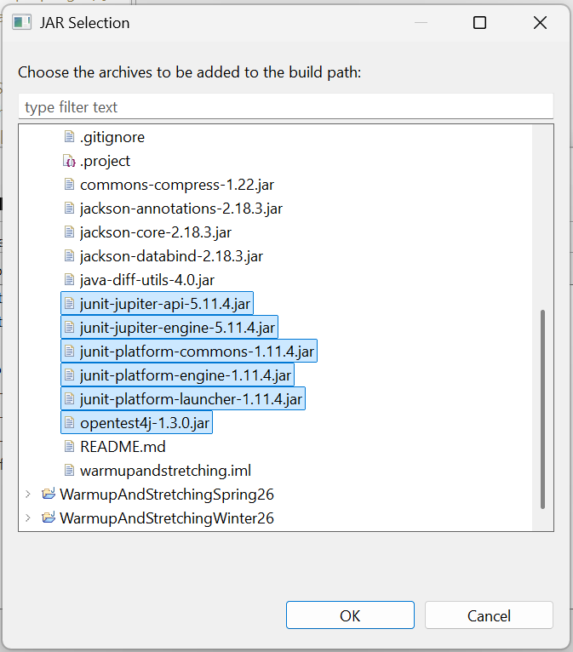
    - Additionally, remove Eclipse’s built-in JUnit 5 library
    - It will look like this:
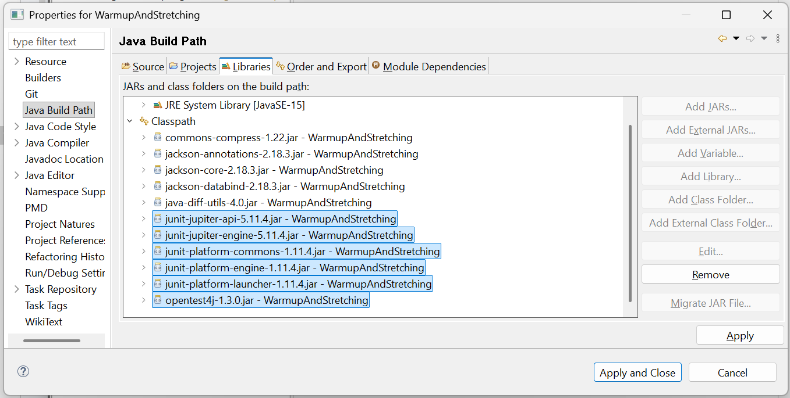
    - The Java version should be 15+

.iml and .idea update
  - If present, delete the current .idea folder and .iml file for the project
  - Paste in the corresponding replacements: Patched .idea and .iml Files

